**25/10/2021 ML LAB 8 2019103573**

**Implement MLP. Use the sigmoidal activation function used in the algorithm in your text book. Fix the number of hidden neurons based on experimentation. With the same number of hidden neurons experiment using three different activation functions.**

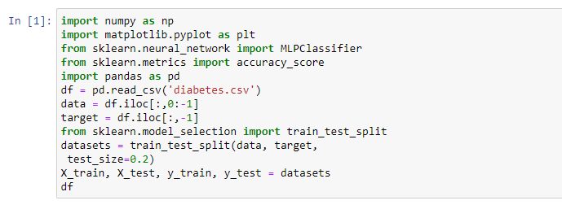**DATASET : Pima Indians Diabetes**

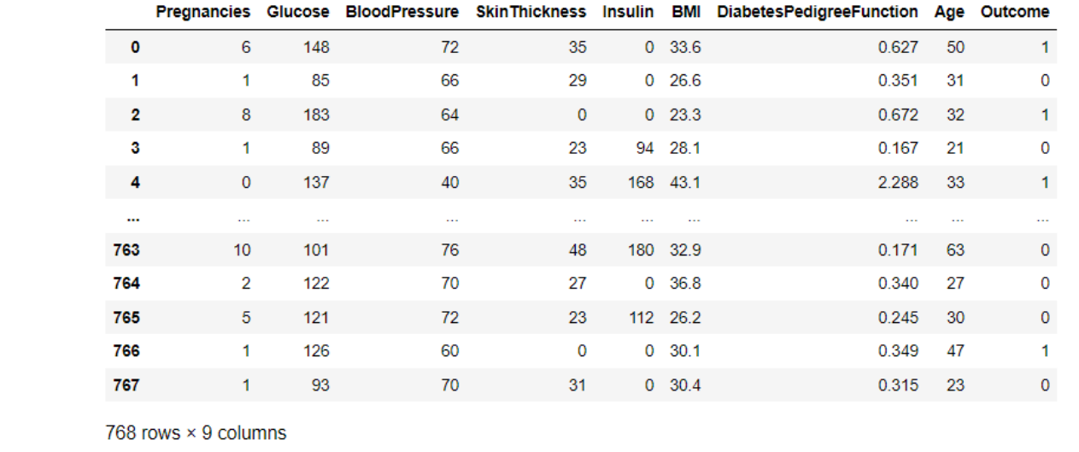

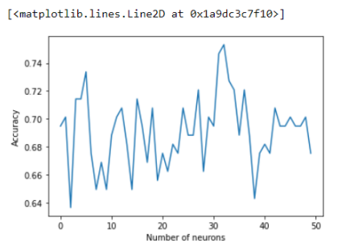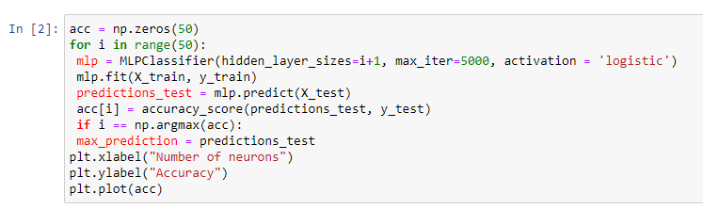

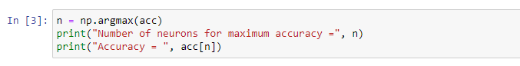

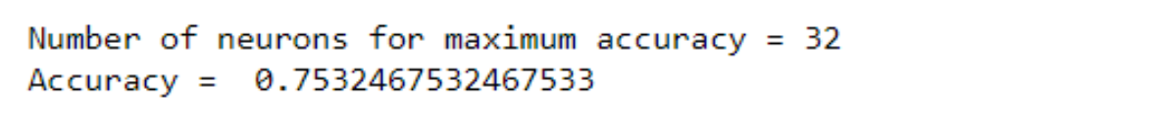

**Performance metrics for sigmoid activation function:**

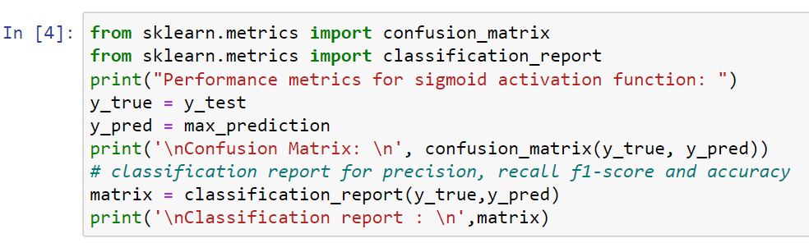

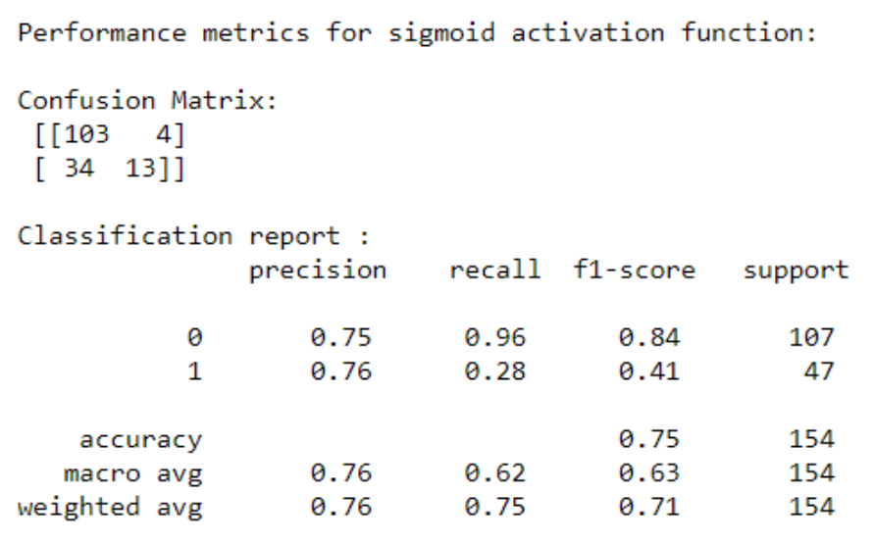

**Rectified Linear Activation Function:**

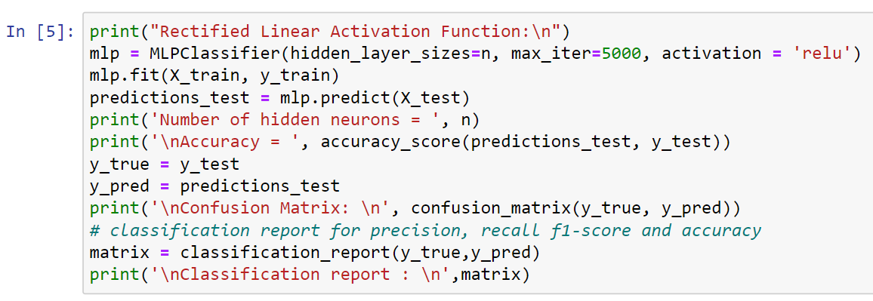

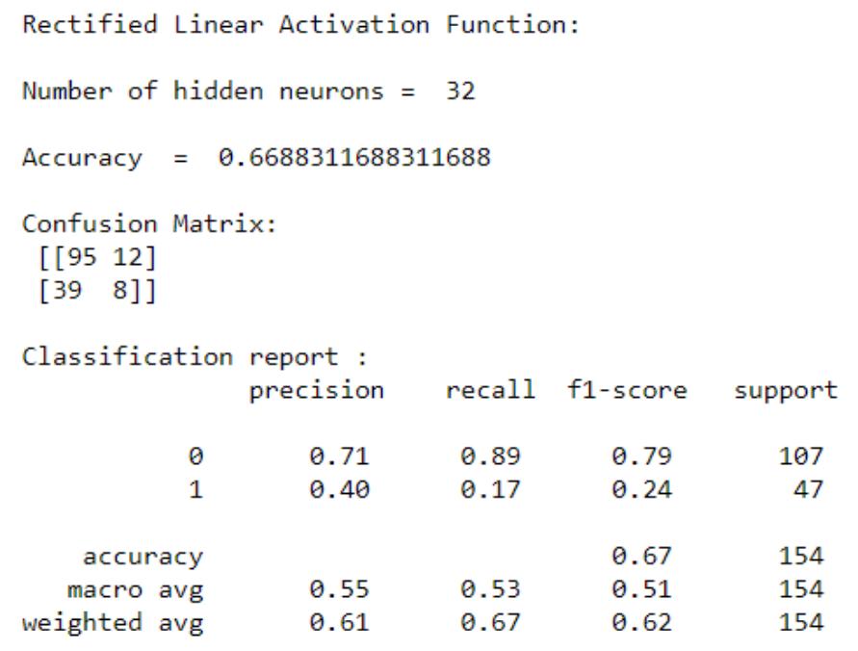

**No Op Activation Function:**

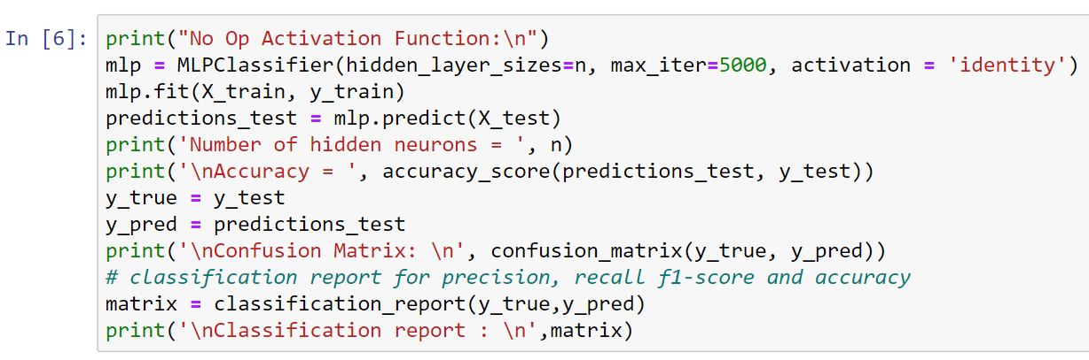

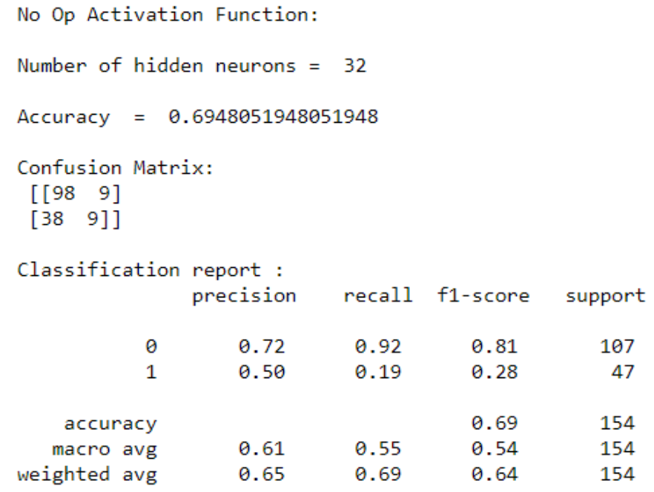

**Choose a dataset suitable for regression and apply regression using MLP**

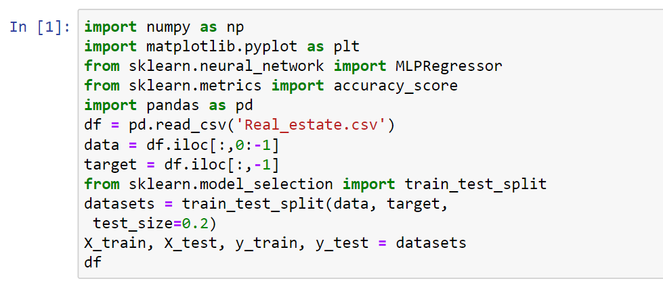**Dataset : Real estate**

